Project Design Phase-I Problem – Solution Architecture

|  |  |
| --- | --- |
| Date | 19 October 2022 |
| Team ID | PNT2022TMID38102 |
| Project Name | Efficient Water Quality Analysis & Prediction using Machine Learning |
| Maximum Marks | 2 Marks |

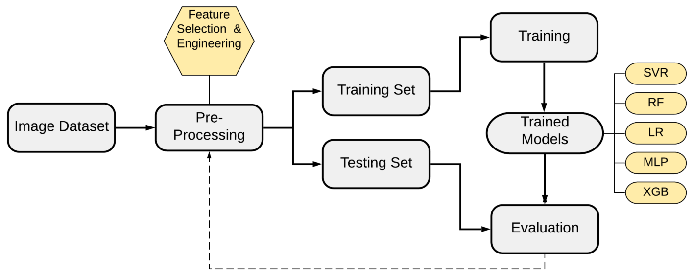

**Output**